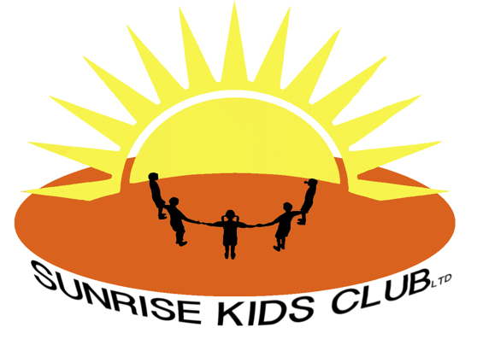

Food and Drink Policy

All food and drink are prepared by staff who have attended a food hygiene course, the food is prepared in a clean and safe environment and complies with The School Food Standards.

Children’s allergies and preferences are taken into consideration when providing snacks. Allergies are recorded on the child’s registration form and all staff are aware of every child’s dietary needs.

Snacks that are provided are always of a healthy nature, Sunrise Kids Club (SKC) promotes healthy eating in line with the school food standards, and we teach the children the importance of having a healthy diet.

Parents and children are consulted about the snack choice and can bring an additional healthy snack from home.

Reviewed November 2024

